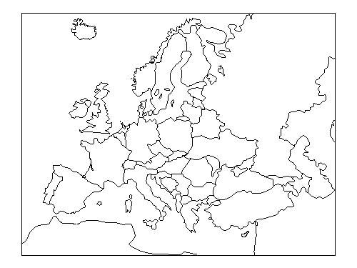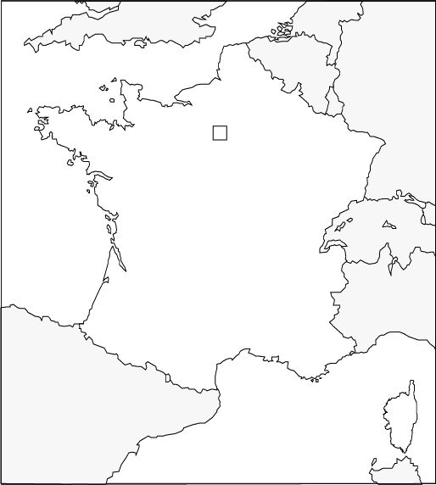

Flag:

Longest River:

Highest Mountain:

Coastline:

Borders with:

Capital City:

Official Language:

President:

Fascinating Facts 2 :

Fascinating Facts 3 :

Fascinating Facts 4:

Currency:

Religion:

Population:

Largest city:

Fascinating Facts 5 :

Information about France

Fascinating Facts 1 :