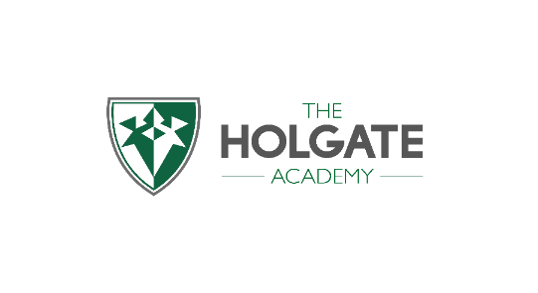Top Tips **Moving on and Moving Up!**



**Write it**

Make a list of any questions you may have so your new teachers, other adults or friends

can answer them.

**?**

**Read it**

Have a go at reading new subject key words. This will help you find your way around your new year group or school and help you get quicker at getting to lessons.

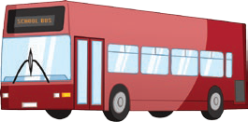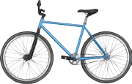

**Travel it**

Have a go at planning your route to school.

If you're travelling by a new mode of transport,

such as the bus or by bike, perhaps try it out

and see how things go. This will help you plan

how long it takes you.

Please check out our school website for information;

<https://www.holgate-ac.org.uk/>

A ‘welcome guide’ containing essential information for parents and students.

<https://www.holgate-ac.org.uk/wp-content/uploads/sites/5/2020/05/The-Holgate-Academy-Essential-Guide-e-version-May-2020.pdf>

Any questions, you can email us;

transition@holgate-ac.org.uk

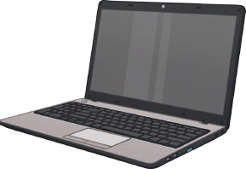

**Find it**

Spend some time looking for new apps, websites and

programmes that can help you get organised and help you with homework or research.