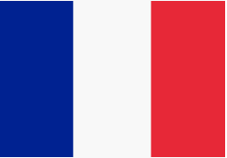
FRENCH SUMMER TASK

Task 1. Are you ready for some numeracy? Here are some sums for you to complete. Answer in French.

Six + deux = huit + un = quatre + sept = dix + dix =

Quinze – neuf = vingt – onze = douze – trois = six – cinq =

Challenge : Create a poster with numbers 1 to 100
Task 3. Can you colour in the rainbow using the correct colours?
Task 2. Can you choose the correct French word from
below and write it under the appropriate colour?
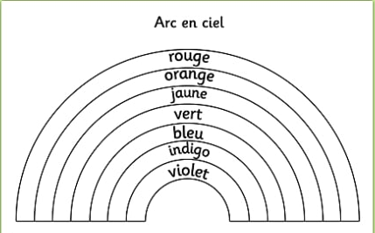
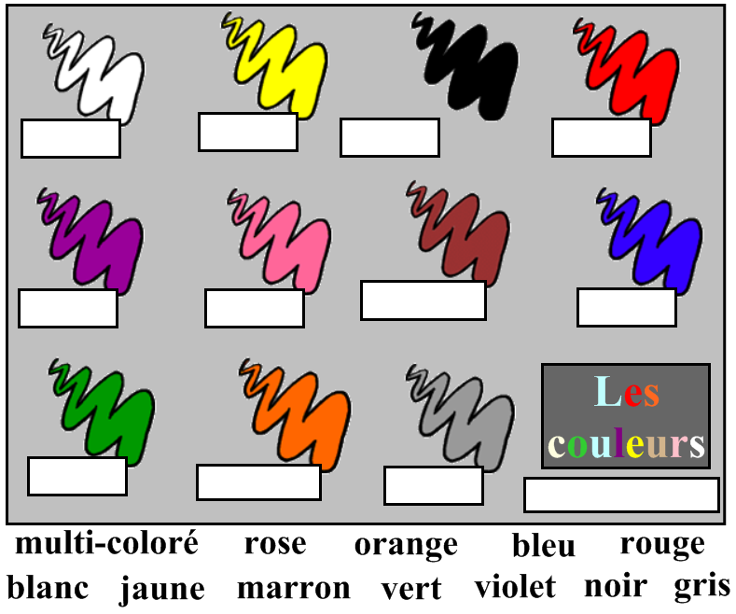

Task 5. Read the paragraph below and answer the questions.
Bonjour! Je m’appelle Sarah et j’ai onze ans. J’habite à Rome, en Italie avec ma famille. Je parle italien, anglais et français. Mon anniversaire c’est le six octobre et ma couleur préférée est bleu. Je suis petite, timide et intelligente.
Au revoir.
- Who has written the paragraph?
- How old are they?
- In which city do they live?
- How many languages do they speak?
- When is their birthday?
- What is their favourite colour?
- What are their three characteristics?

Task 4. Can you match-up the French words to their English translation ?
Intelligent/ intelligente
Bavard/ bavarde
Marrant / marrante
Têtu/têtue
Paresseux/paresseuse
Sérieux/sérieuse
Sympa
Timide
Stupide
Egoïste

chatty
selfish
lazy
serious
nice
shy
funny
intelligent
stubborn
stupid

Challenge : write some sentences to describe what sort of
person you are? Je suis…. (I am …)

Task 6. Many words in French look and mean the same in English but are pronounced differently. See how many sports you can find in the word search below. Can you recognise what they are?
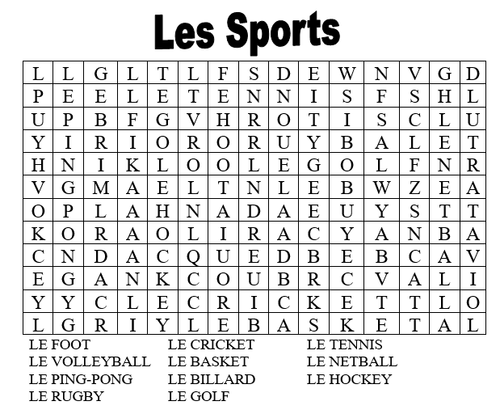
Task 7. Using the sentence starters below, write down 5 sentences about sports you prefer, love or hate. Je préfère ………………………………………………………………………………………..
- J’adore…………………………………………………………………………………………….
- Je déteste ……………………………………………………………………………………….
- J’adore …………………………………………………………………………………………..
- Je préfère ……………………………………………………………………………………….
Challenge : Can you translate them into English?

Task 8. Colour the flags below – which country do they represent? L’Italie, L’Irlande, La Belgique
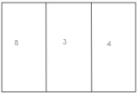
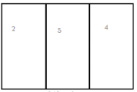
2
5
7

1= bleu foncé 2= vert 3= jaune 4= rouge 5= blanc
6= bleu 7= orange 8= noir 9= bleu clair

