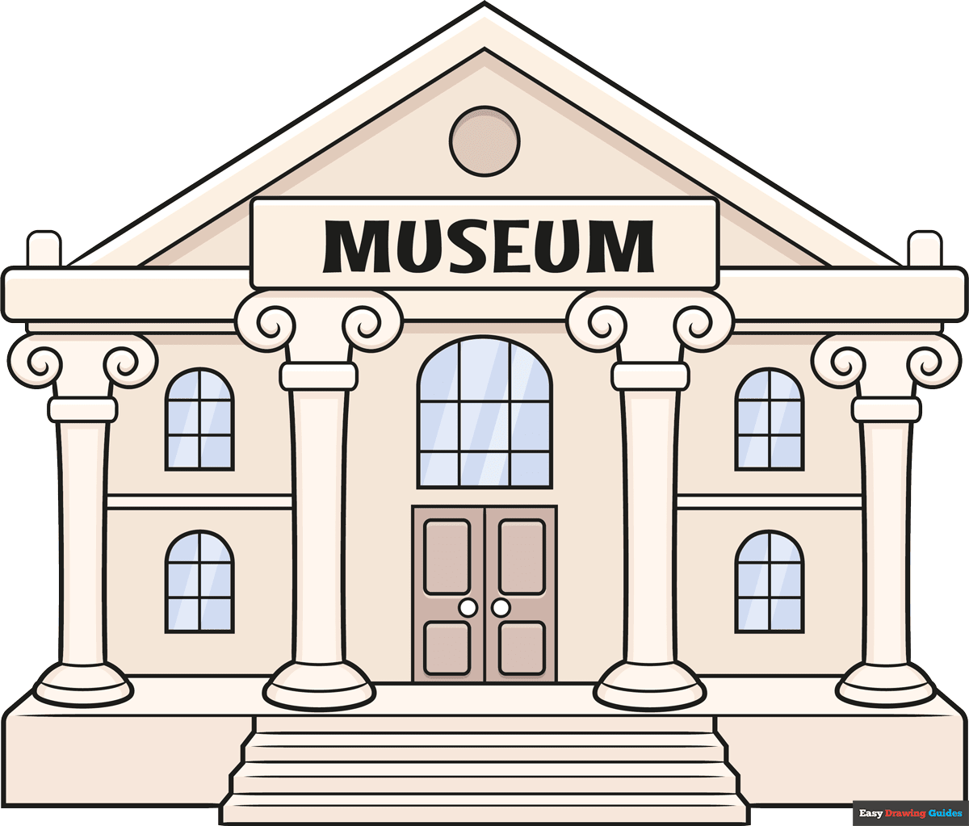
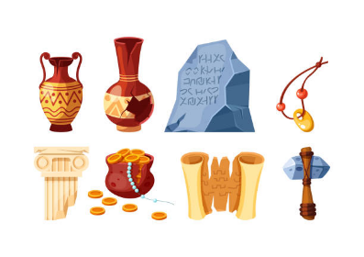
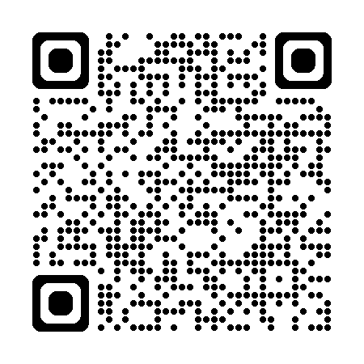

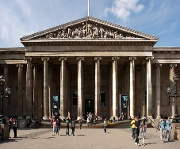
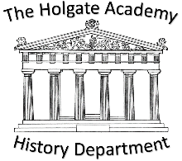
History Transition Homework
Create your own History Museum or Gallery

- Choose a History topic that you are interested in. It
could be any time period or event / person that you like.
- Next research about the topic and create your own museum about that event or person.
- You can only select a maximum of 10 artefacts (objects) or pieces of information to include in your museum display.
- Your chosen objects should aim to tell people visiting your museum:
  - Key facts about the time period / event / person
  - Why the time period / event / person is important
You may want to create models of the artefacts that you decide to include.

Scan the QR code have a look at online
exhibition for Queen Elizabeth II at
The National Gallery!

Challenge: Can you make a poster encouraging people to come and visit your museum? Think about:
- Where will your museum be?
- How much will it cost?
- Will there be any snacks and refreshments?
- What times will the museum be open?
- But most importantly… Why should they come to the Museum?

